Product Design
Team Django Untrained

Architectural Overview
Browser

Template

URL Dispatcher

View

Model
Database

Model: Model includes the database schema which is inbuilt as part of Django, also this is an encapsulation of Django components
Views – View describes which data is presented to the user. View delegates to a template which indicates how a data is presented to the user.

Components and Functions

Sl No | Name | Description
1 | User | Component state  - User account credentials  - Personal user information (name, address, contact information)  - Sharing preferences  - Tools owned  Component behavior  - Allows for user to manage and update personal information. Updating user’s address to an area with different zip code will trigger the system to evaluate whether or not the user must be placed into a new share zone or if a new share zone must be created.  - Allows for user to manage/update account preferences  - Maintains a list of all tools registered by the user  - Handles changing passwords as well as resetting of passwords by providing their e-mail in case user forgets  - Handles e-mail notifications to the user
2 | System | Component state  - List of share zones  Component behavior  - Handles creation of new users and saving them to the database  - Allows a new user to register for Tool Share and places them in a share zone. Under the hood: If share zone does not yet exist in user’s area, system will create a new share zone and append it to its list of share zones.  - Maintains a list of share zones  - Able to generate community statistics  - Handles user logging in or out of Tool Share and authentication
3 | Share Zone | Component state  - Zip code of share zone  - List of users in share zone  - List of sheds in share zone  Component behavior  - Allows for instantiation of a new share zone object  - Maintains a list of users and sheds in the share zone  - Able to generate a list of all the tools being shared in the share zone
4 | Shed | Component state  - Shed name  - Shed address  - Shed coordinator  Component behavior  - Allows for instantiation of a new shed object  - Allows shed information to be changed
5 | Tool | Component state  - Tool information (name, picture, description)  - Tool sharing location  - Tool active status (activated/deactivated)  - Tool owner  - Tool blackout dates  - Tool sharing status (available/borrowed/return pending)  - Tool reservations list  Component behavior  - Allows for instantiation of a new tool object  - Allows the tool sharing location to be changed to user’s home address or a specified shed address  - Allows for tool to be activated or deactivated on Tool Share  - Allows for sharing status of tool to be updated  - Manages reservations on the tool  - Manages blackout dates on the tool  - Allows tool information to be changed/updated
6 | Reservation | Component state  - Borrower  - Reservation message  - Reservation date  - Reservation status (pending, approved or rejected)  Component behavior  - Allows for instantiation of a new reservation object  - Handles displaying reservation information  - Keeps track of whether or not the lender has approved or rejected the reservation
7 | Address | Component state  - Address information (apartment, street, city, zip code, country)  Component behavior  - Handles updating of address fields

Class Diagram(s)
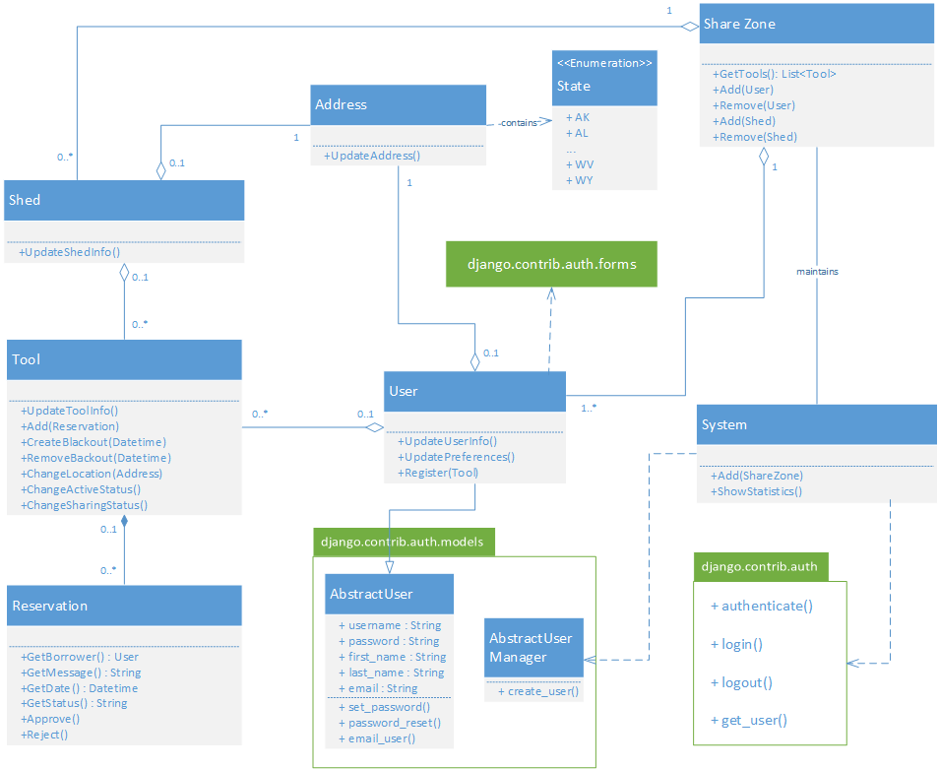

Sequence Diagram(s)
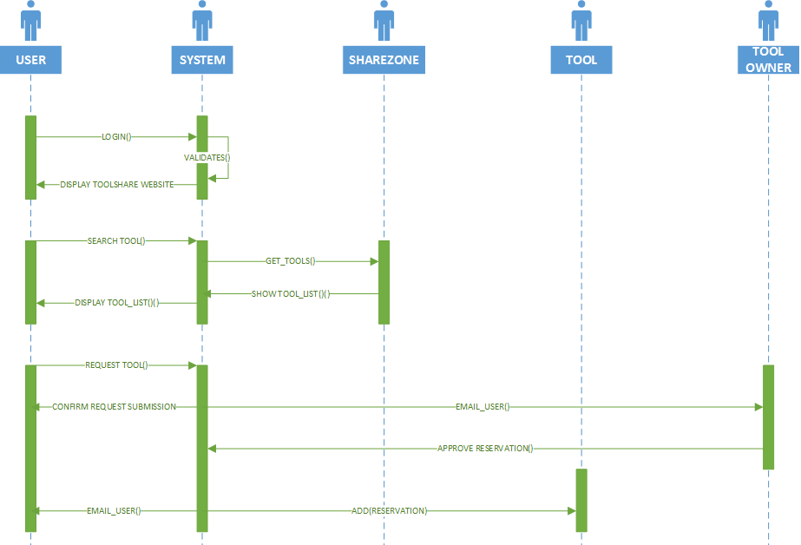

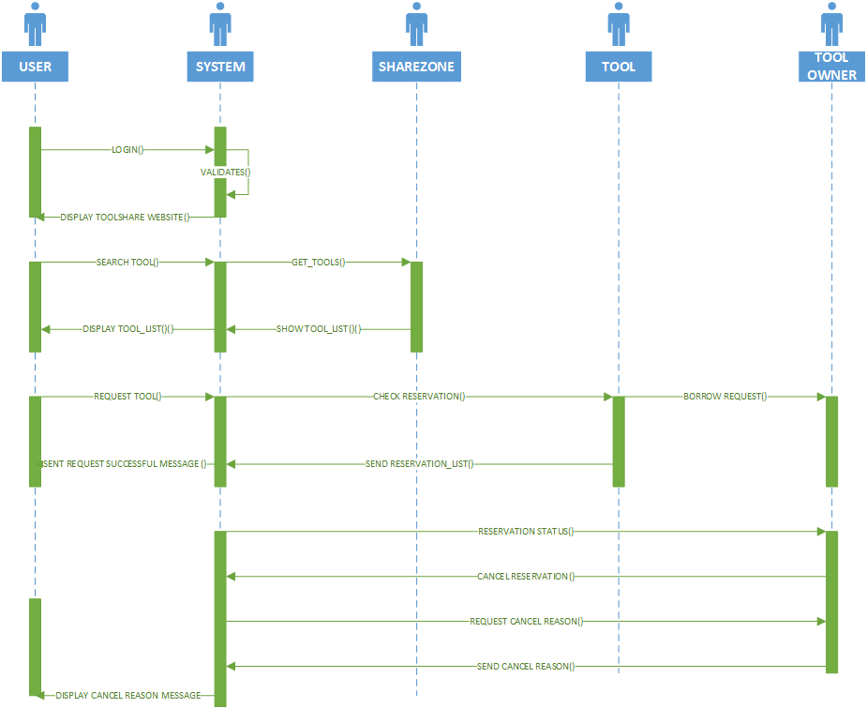

Design Rationale
- Started by brainstorming classes that we believe to be important to include in the UML class diagram. Results were user, tool, share zone, shed, and reservation
- Decided that user should be a superclass which is extended by Lender, Borrower and Shed Coordinator since it includes functionality common to all 3 types of users
- Brainstormed attributes that should be common to all users: personal information, sharing preferences, and account information. Common methods include registering user to system and updating user information
- Decided that the “Registrant” concept is not necessary – it is merely a user with null fields which will be populated once correct information is entered in the registration page
- Decided that share zone class should maintain a list of users and sheds for organization purposes
- Created a System class which will maintain a list of share zones.
- Decided that system would handle many user authentication tasks, login and logout
- Changed previous decision to have class diagrams for Lender, Borrower and Shed Coordinator. The system only knows the concept of a user. Based on different contexts, the users will act as a Lender, Borrower or Shed Coordinator. Ex: when user creates a reservation on a tool, they are acting on the tool class as a borrower. This is because we believe that although having different types of users helps us conceptualize how Tool Share works, it does not make sense from an implementation standpoint (we don’t want to create and associate up to three types of users to the same person)
- Decided that the user should not have a register method. Added this method to the system class, since it does not make sense for us to have a null user object before the registrant clicks register. By making this change, a null user object is now only created after a registrant submits their registration form. System makes a null user object, populate its fields and then add it to the appropriate share zone or create a new share zone if it does not yet exist.
- Added list of share zones attribute to system. When user chooses to list tools in their share zone, it looks up the share zone that they are assigned to. The share zone object knows all the users and sheds in it, and so it looks at all the tools owned by those users and in those sheds and composes a complete listing of tools to show to the user.
- Instead of keeping track of tools located at user’s home or in a shed by maintaining a list of tools at each location, the tool itself now has a sharing location attribute. The user’s list of tools will now be all the tools that they own. The shed will no longer need to maintain a list of tools, since each tool will know if it is located at a shed. Therefore, when search tools is invoked from the system class, it will simply iterated through all the users in the share zone and list the tools that they own if they are not deactivated
- Removed many methods from system class as well as attributes from the user class because they are provided for by Django authentication. Added the appropriate Django classes to the UML and displayed the relationship to the existing classes.
- User Moves to New Share Zone

- Home reservations
- Approved - user must first cancel, notify borrower by email
- Rejected – no action
- Pending – auto reject, notify borrower user has moved
- Cancelled – no action

- Shed Reservations
Relocate tool back home, follows above logic for reservation handling

- Sheds
- Delete shed
- All tools are relocated back to owner’s home, follows shed reservation logic

- Tools

Borrowed tools
- Warn user he has borrowed tools
- Notify owner that user has moved
- Moving Tool
- Home to Shed
- Active approved reservation – Wait till the reservation period is over
- Future reservation – move and notify
- Rejected – no action
- Pending – auto reject
- Cancel – no action
- Shed to Home
- Active approved reservation – wait till the reservation period is over
- Future reservation – move and notify
- Activating/Deactivating Tool
- Active -> Inactive
- Active approved reservation –Cannot Deactivate
- Future reservation – Cannot deactivate
- Pending – cannot deactivate
- Status of tool displayed on the website – no computation logic is done based on the dates. A job – similar to a cron job is designed to automatically modify the status of tools. Any tool reservation which ends on the current date is changed to “overdue” in the application.

- Status of reservation added after R1
- ('A', 'Approved'),
- ('AC', 'Active'),
- ('C', 'Cancelled'),
- ('CL', 'Closed'),
- ('O', 'Overdue'),
- ('P', 'Pending'),
- ('R', 'Rejected'),
- ('RA', 'Return Acknowledged'),
- ('RC', 'Recalled'),
- (‘RI’, Return Initiated)

